**Database- Day -3: MongoDB Task**

**For the following question write the corresponding MongoDB queries**

1**. Find all the information about each products**

**MongoDB queries:**

**db.products.find({})**

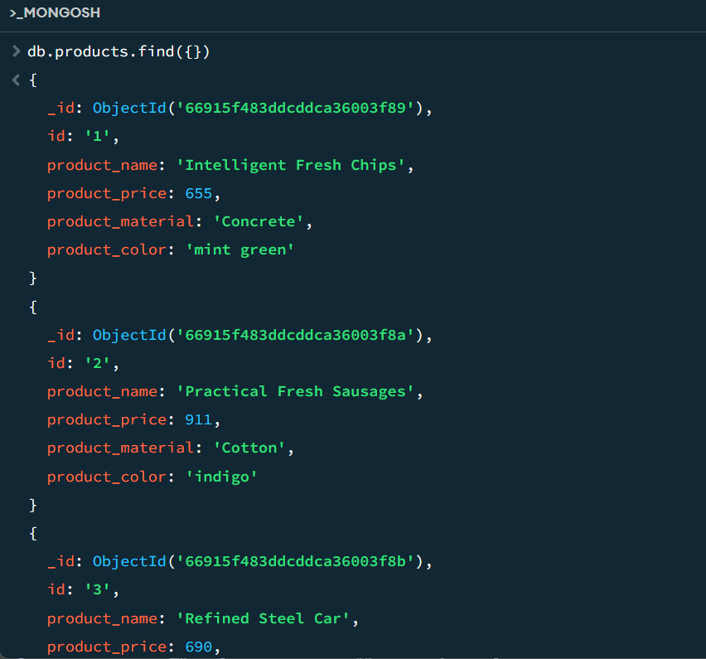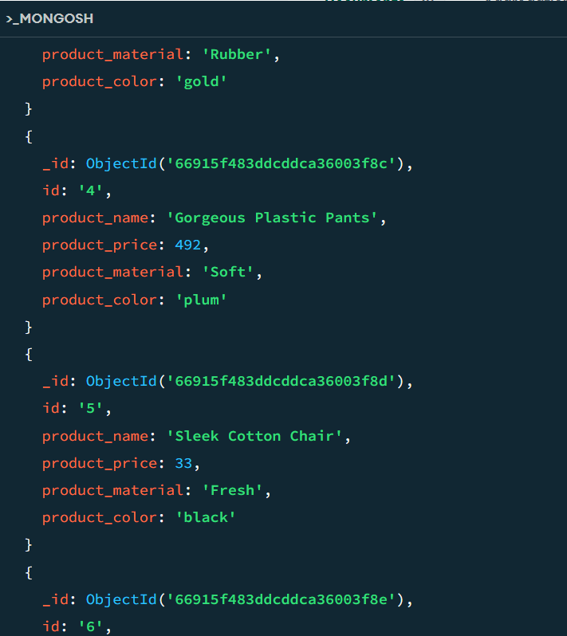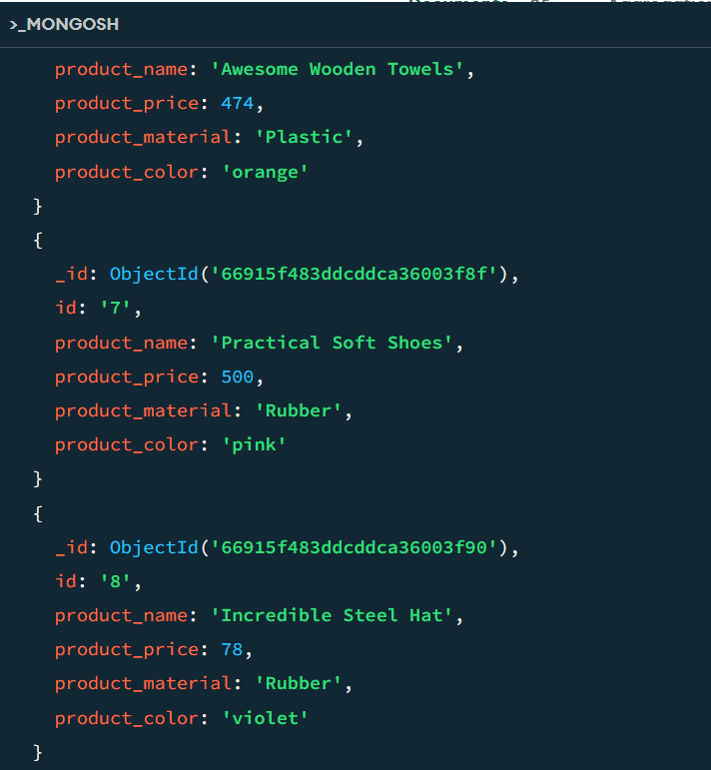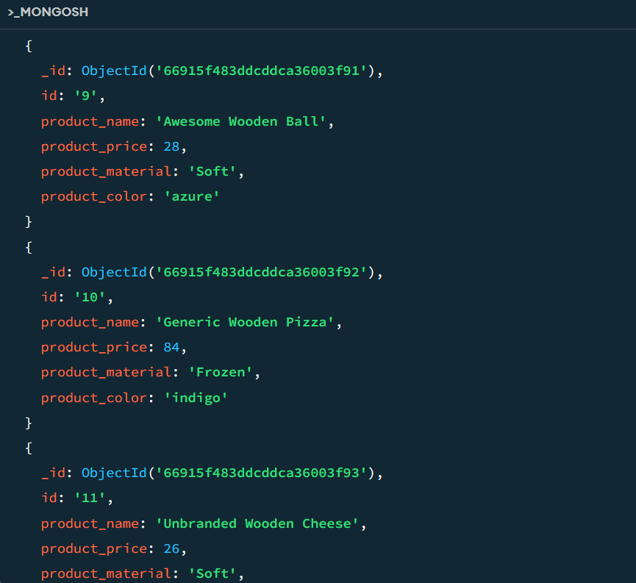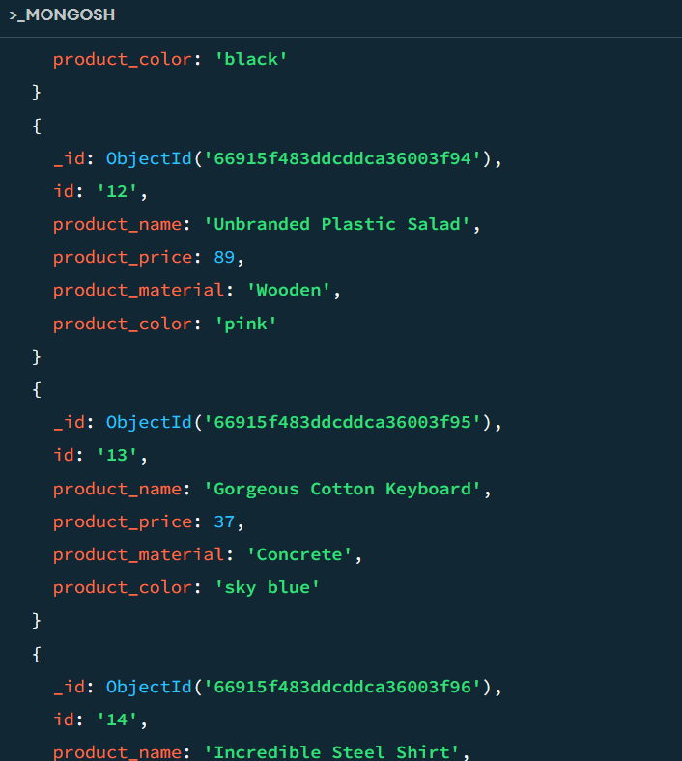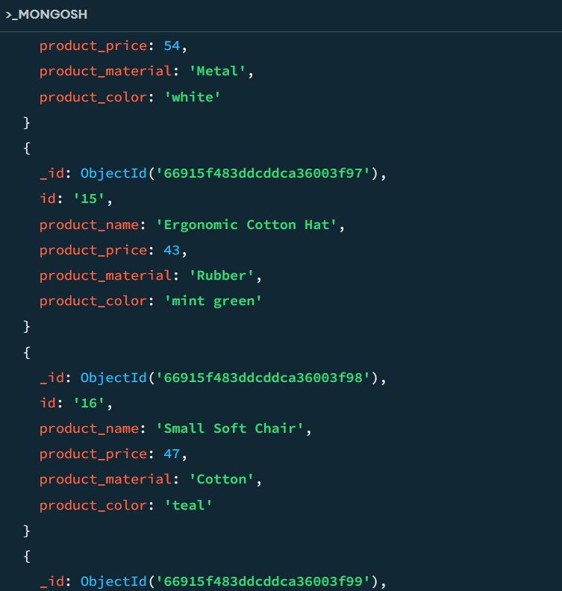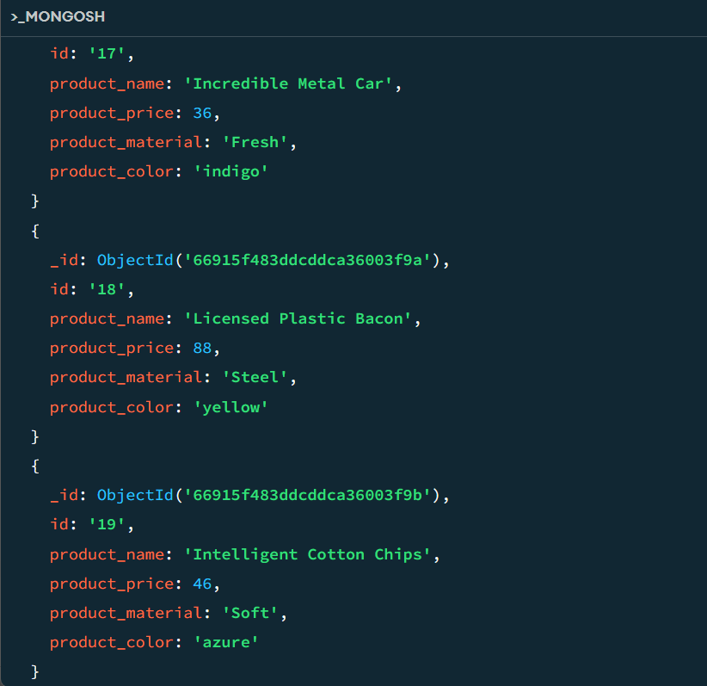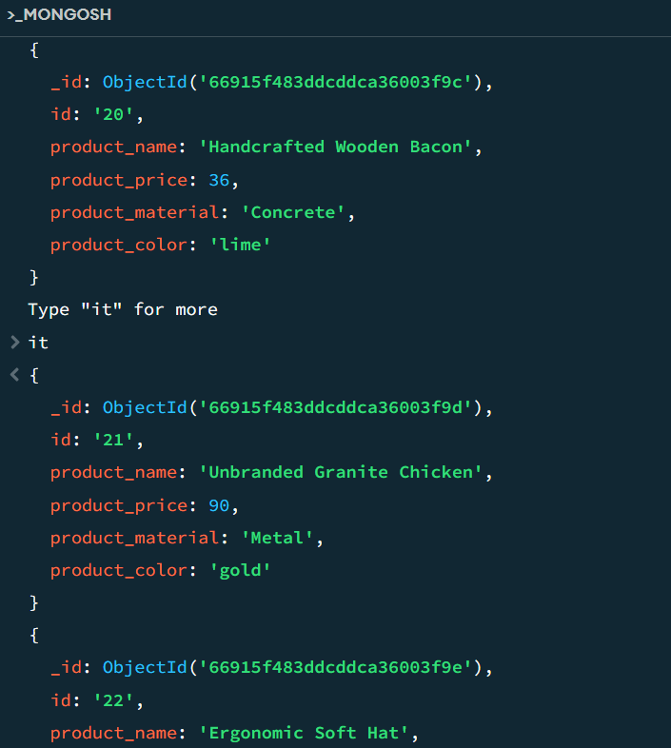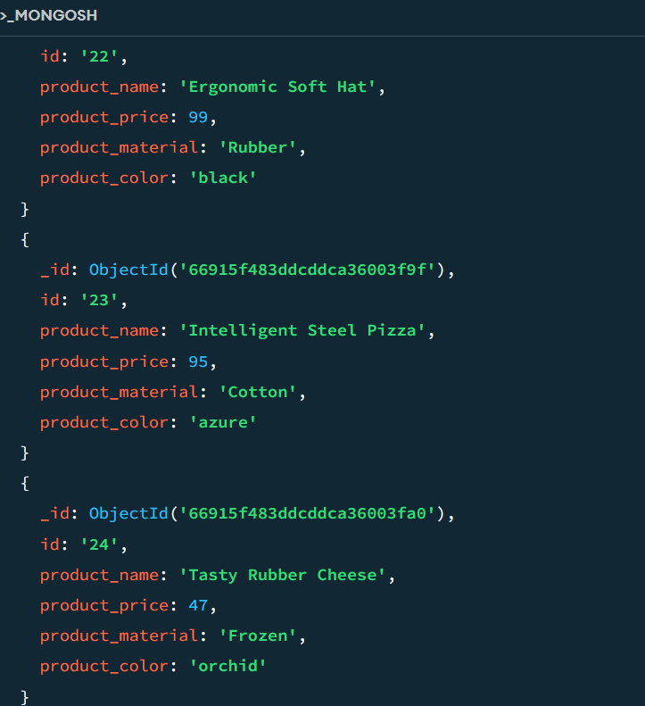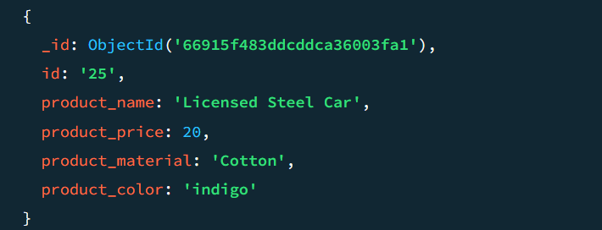

**2. Find the product price which are between 400 to 800**

**MongoDB queries:**

**db.products.find({ product_price: { $gte: 400, $lte: 800 } })**

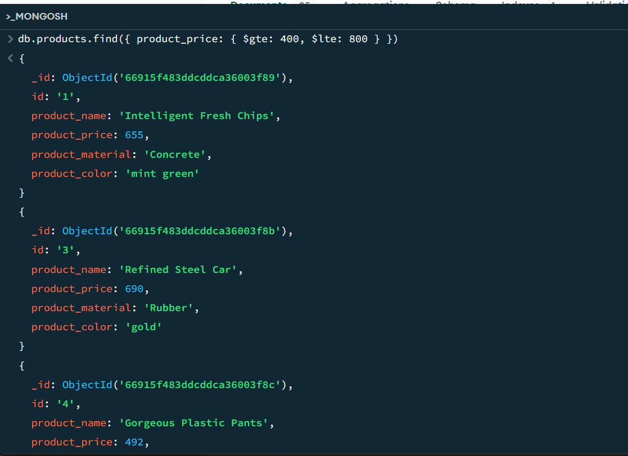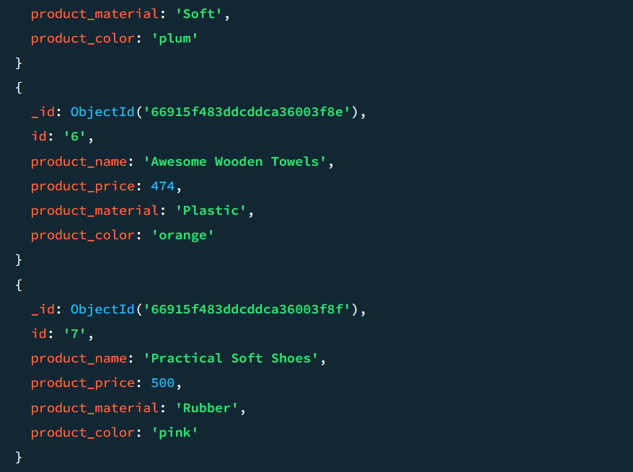

**3. Find the product price which are not between 400 to 600**

**MongoDB queries:**

**db.products.find({ $or: [**

**{ product_price: { $lt: 400 } },**

**{ product_price: { $gt: 600 } }**

**] })**

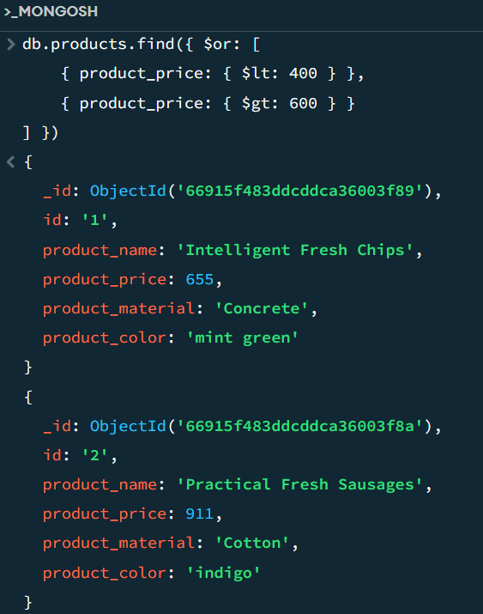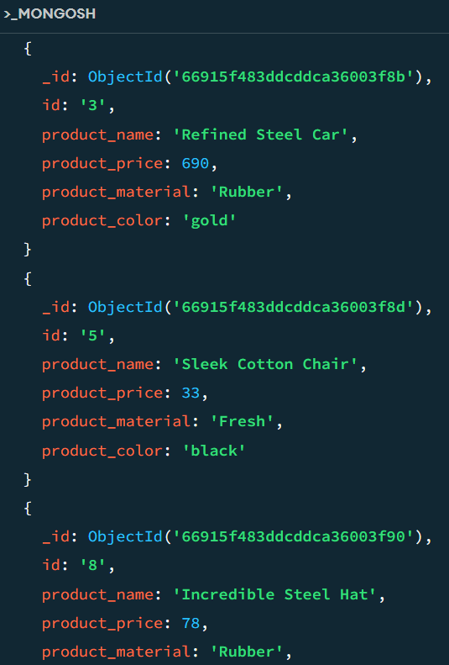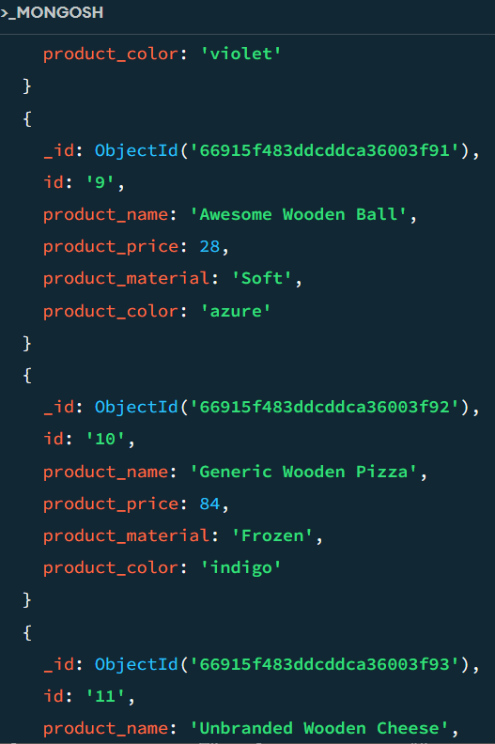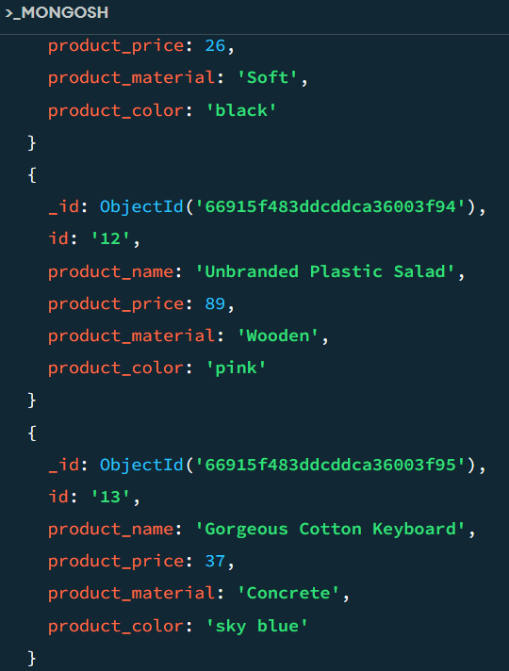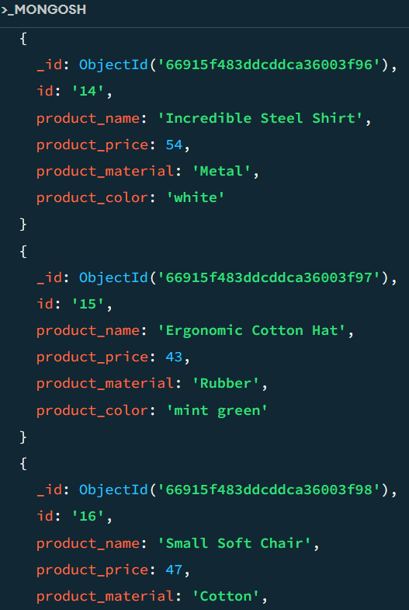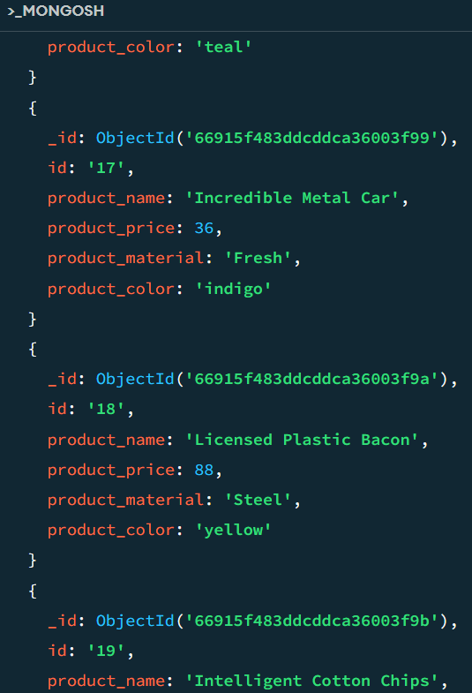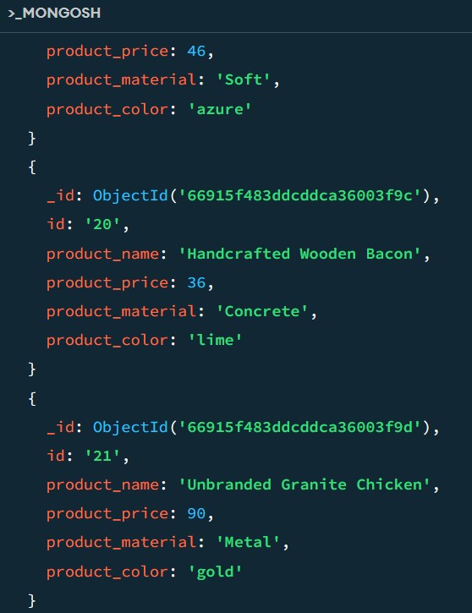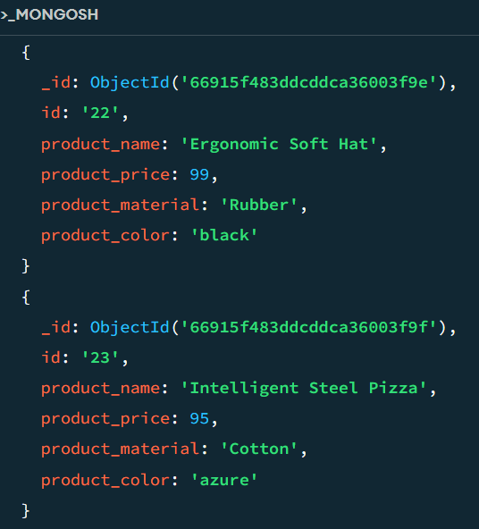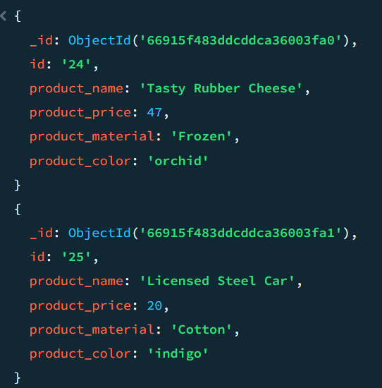

**4. List the four product which are greater than 500 in price**

**MongoDB queries:**

**db.products.find({ product_price: { $gt: 500 } }).limit(4)**

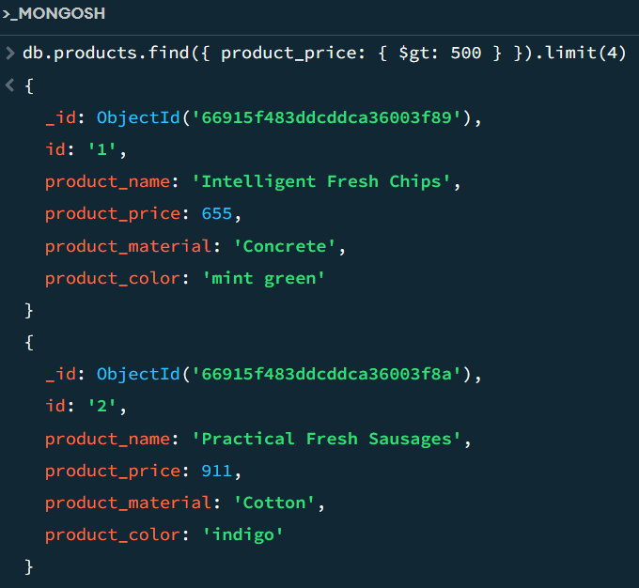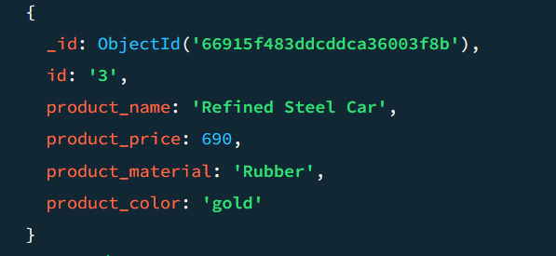

**5. Find the product name and product material of each products**

**MongoDB queries:**

**db.products.find({}, { product_name: 1, product_material: 1, _id: 0 })**

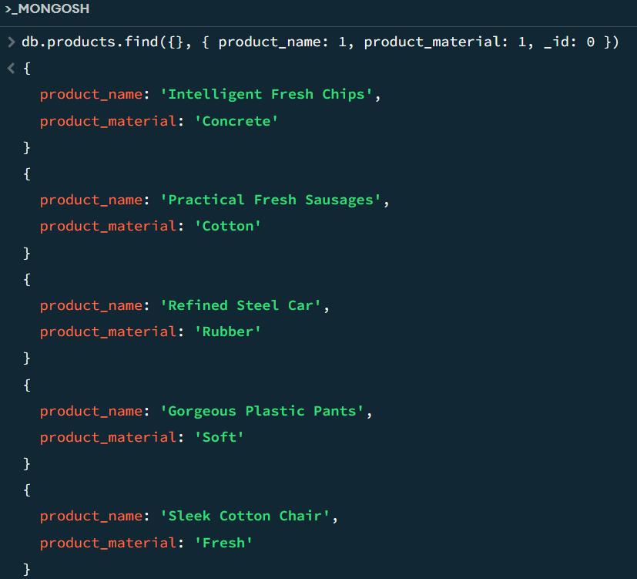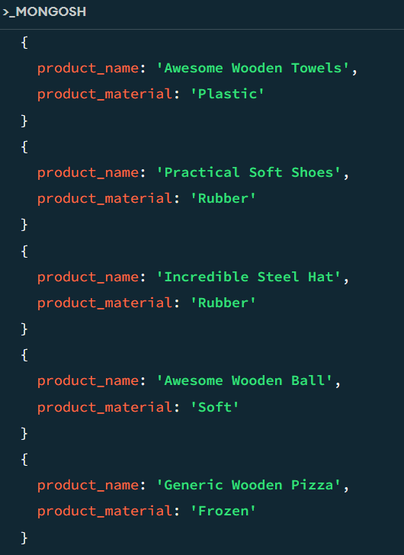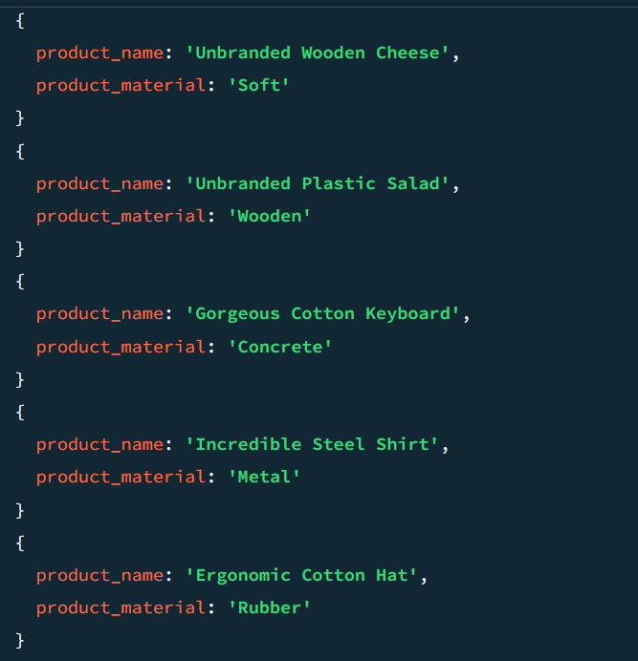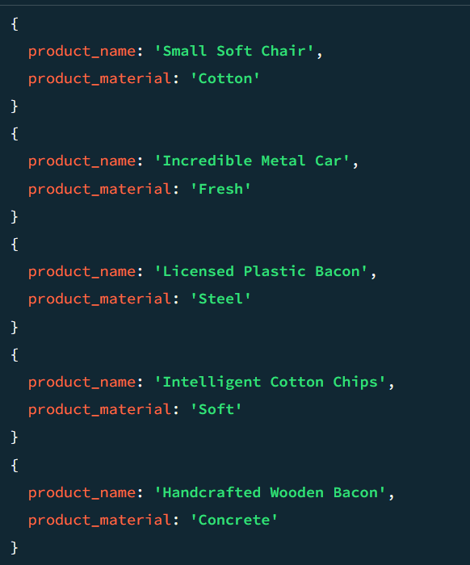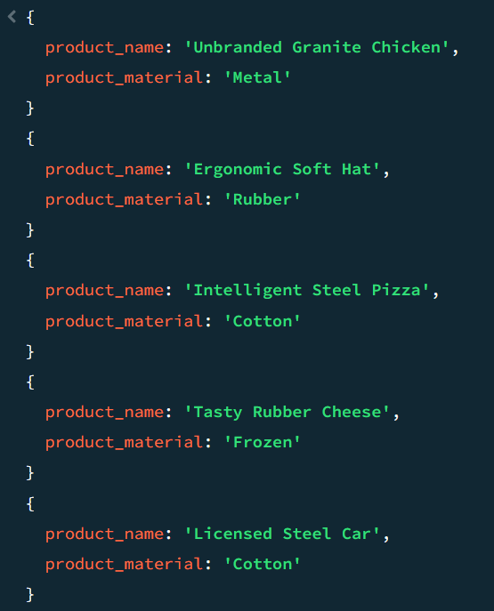

**6. Find the product with a row id of 10**

**MongoDB queries:**

**db.products.findOne({ id: "10" })**

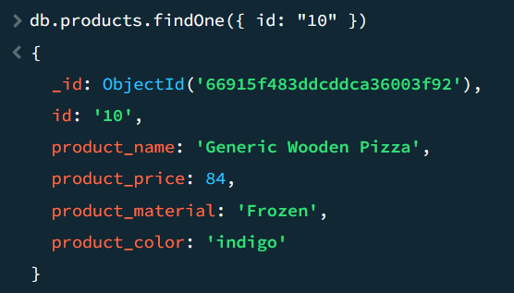

**7. Find only the product name and product material**

**MongoDB queries:**

**db.products.find({}, { product_name: 1, product_material: 1, _id: 0 })**

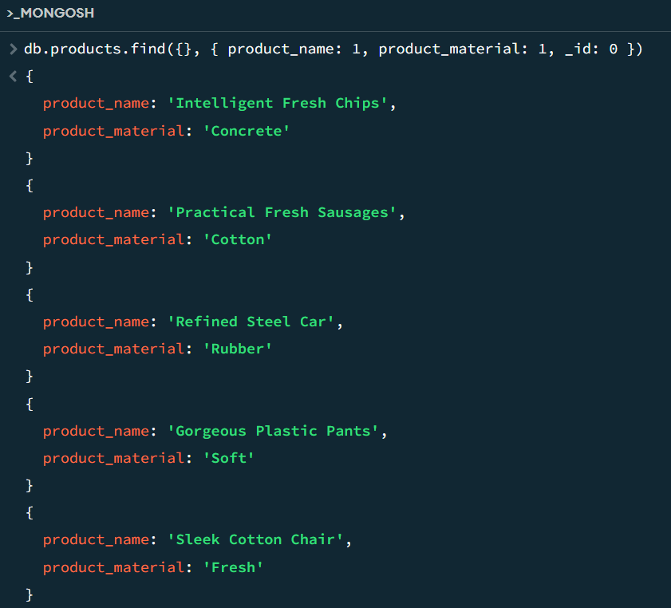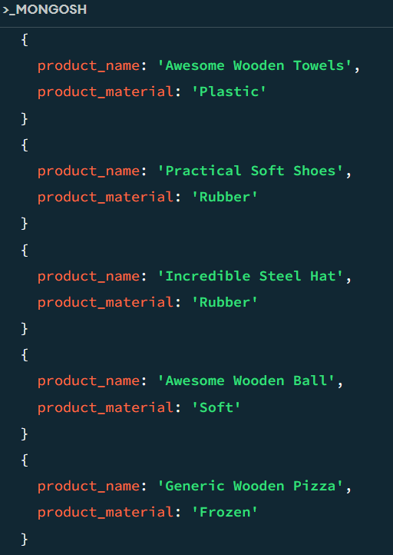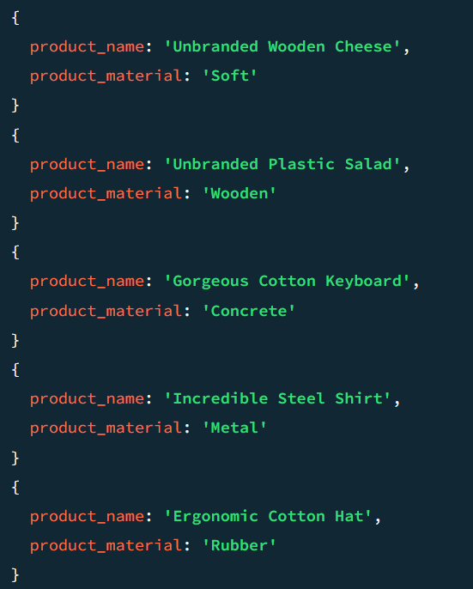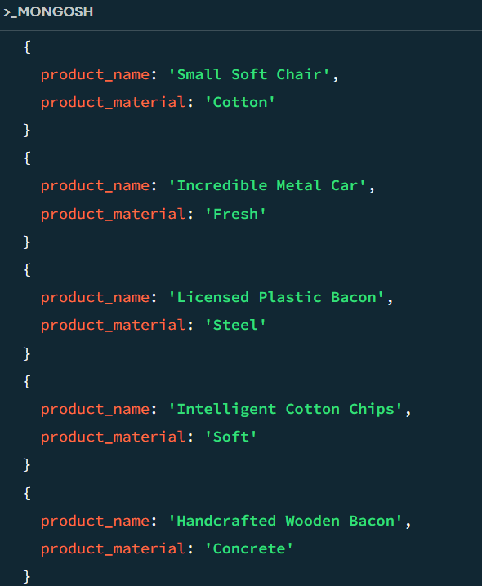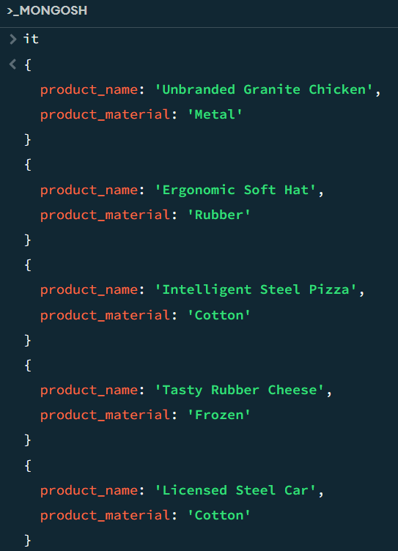

**8. Find all products which contain the value of soft in product material**

**MongoDB queries:**

**db.products.find({ product_color: "indigo", product_price: 492.00 })**

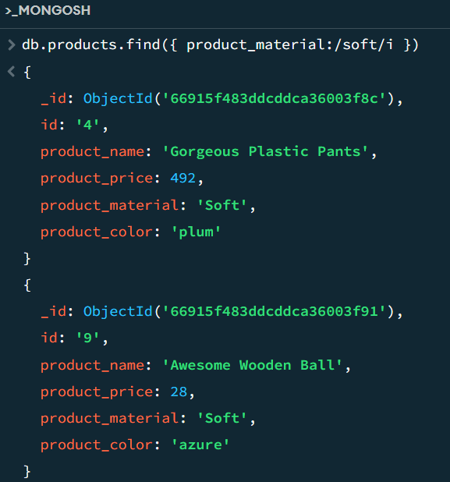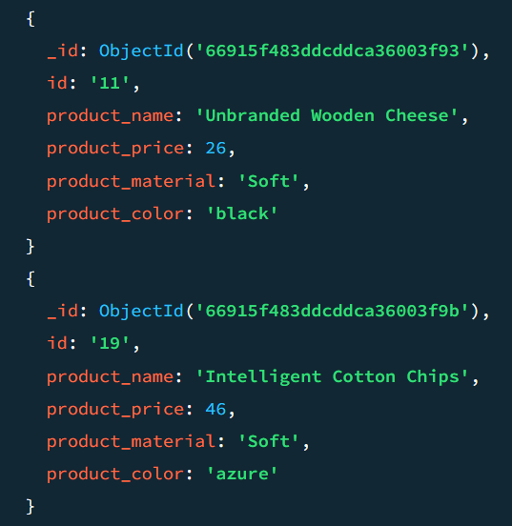

**9. Find products which contain product color indigo and product price 492.00**

**MongoDB queries:**



**10. Delete the products which product price value are 28**

**MongoDB queries:**

**db.products.find({ product_color: "indigo", product_price: 492.00 })**

